- Purpose
  - The purpose of this document is to describe the procedure for assembling the Solution Tank on the 20” Genesys Machine.
- Scope
  - This SOP applies to all equipment assembly team members. The process applies to the following machine ID’s:
EP50291EQS0600BE1200 – Solution Tank, G20
- Responsibilities
  - The operations manager/supervisor is responsible for enforcing this SOP.
- Materials
  - The proper materials needed for this process are listed on the machine work order.
- Definitions

- Procedure
  - Start with a solution tank (E28889). Flip it over so that the bottom is exposed.

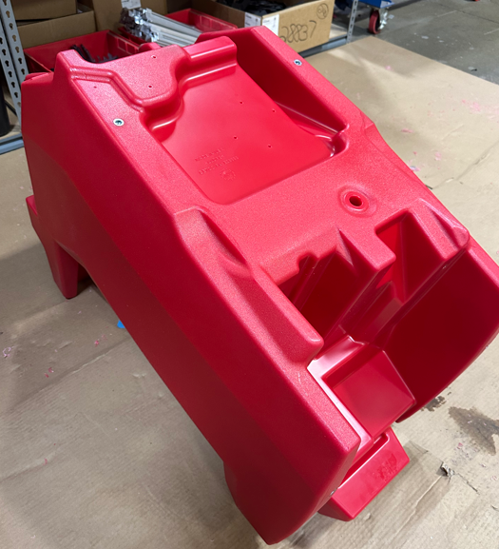

  - Use a 1 ¾” diameter hole saw to cut out the rear fill port. There is a drill point in the tank to mark the location. Try as best as possible to keep as many shavings out of the tank as possible.

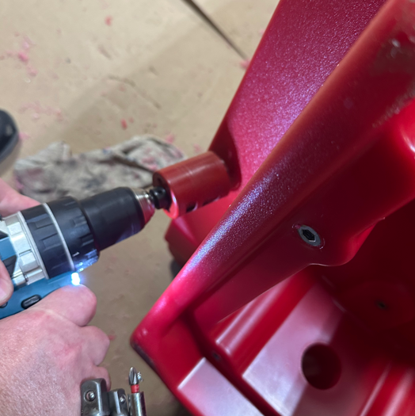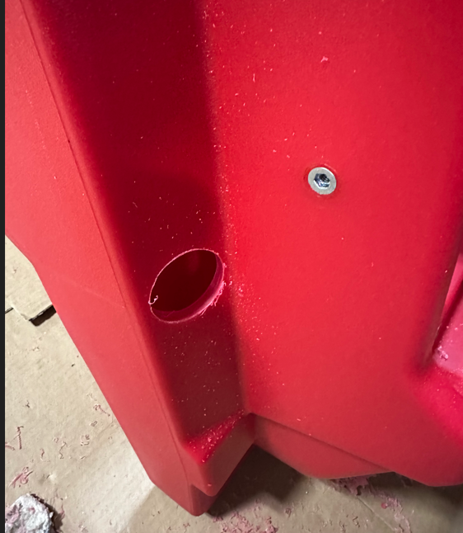
  - Use a 45/64” drill bit to drill out each end of where the sight tube will go. Take care to ensure the hole is straight and is not allowed to “oval”. There are drill points in each location to mark the correct spots. Try as best as possible to keep as many shavings out of the tank as possible.

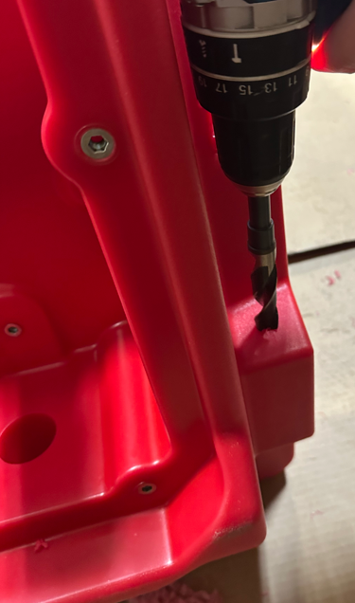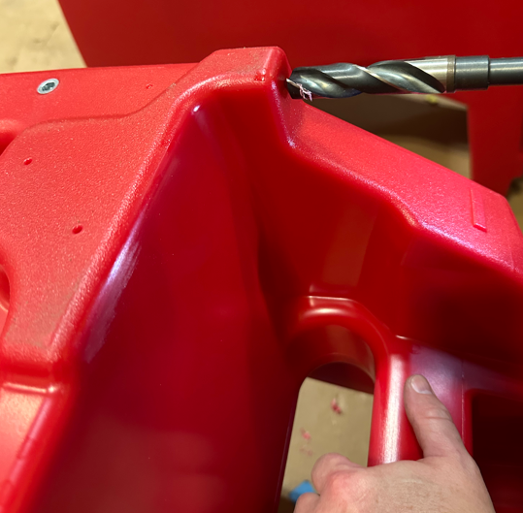
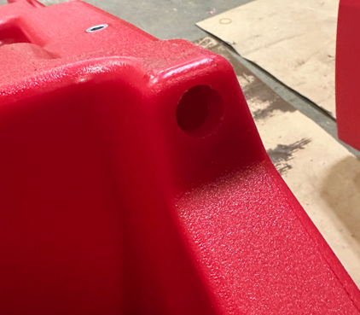

  - Use a 9/16” drill bit to drill out the ball valve mounting location. Take care to ensure the hole is straight and is not allowed to “oval”. There is a drill point in the tank to mark the location. Try as best as possible to keep as many shavings out of the tank as possible.

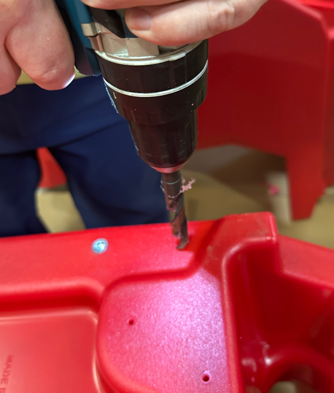
  - Use a 3/8” NPT tap to tap out the hole for the ball valve. Again, try to keep as many shavings out of the tank as possible. Ensure the tap is aligned properly and not angled.

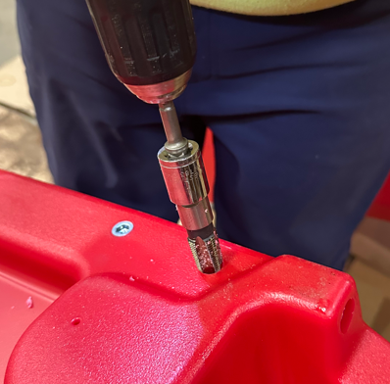

  - Use a ½” NPT tap to tap out the holes on each end of the sight tube. Try to keep the shavings out of the tank. Ensure the tap is aligned properly and not angled.

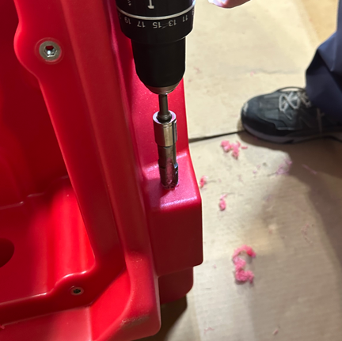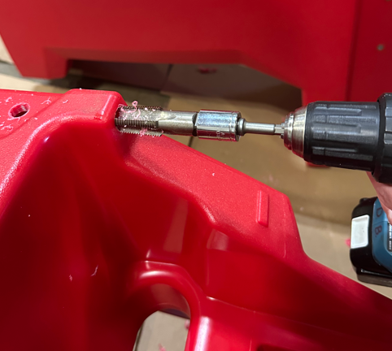

  - Take the tank to the rinsing station, and rinse it thoroughly to flush out any remaining shavings that got into the tank. Allow the tank to drain completely when finished.

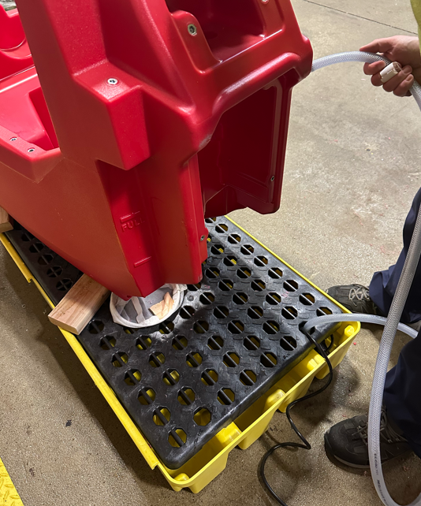
  - Take the upper sight tube fitting (E28913) and use a piece of sandpaper to round off the edges of the barb. This will allow for easier hose removal when the tank needs drained.

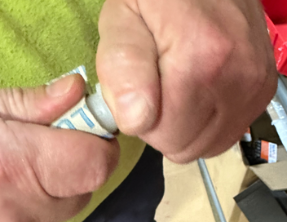

  - Thread to fitting into the appropriate hole. No tape or thread sealant is needed as this will be above the water line.

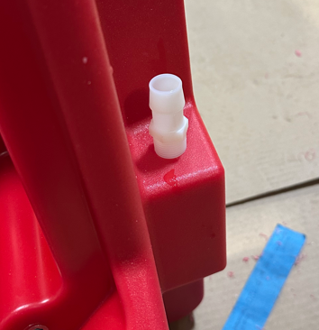

  - Take the lower sight tube fitting (E28913) along with the solution ball valve (E28999) and put a little bit of thread tape on the threads.

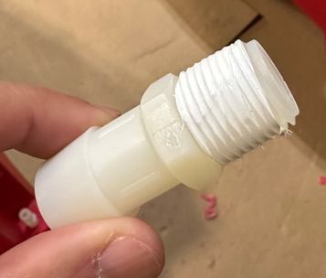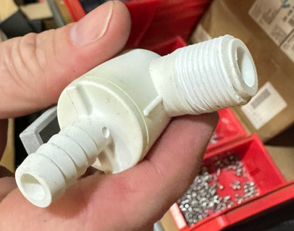
  - Take some of the blue thread sealant and put some in the two tapped holes shown. Also put some onto the two fittings that were just taped.

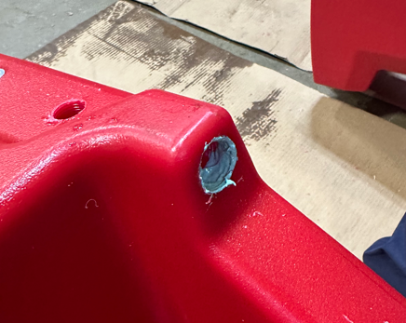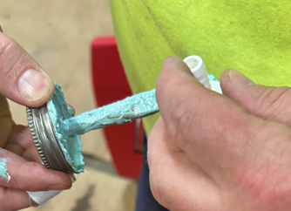

  - Thread the lower sight tube fitting and tighten it appropriately. Since this is an NPT fit, it does not need tightened until the shoulder bottoms out. There should be a couple of threads showing.

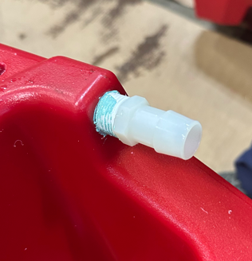

  - Thread the ball valve into the appropriate hole. Since this is an NPT fit, it does not need tightened until the shoulder bottoms out. Ensure the barb is oriented as shown so that it lines up with the filter in another step.

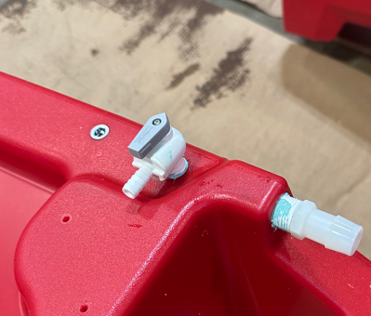
  - Cut a 24” piece of ¾” tubing (E28922) for the sight hose. Push one end of it onto the lower sight tube fitting and secure it with a worm clamp (E28766). Push the other end onto the upper sight tube fitting.

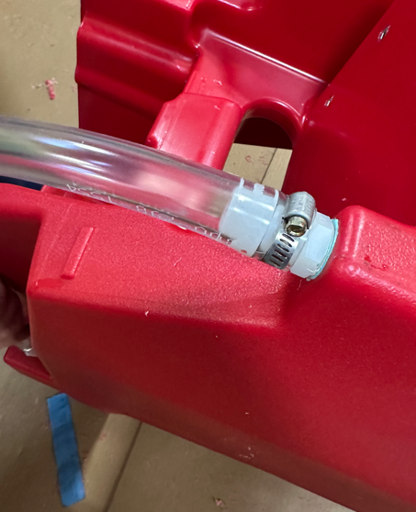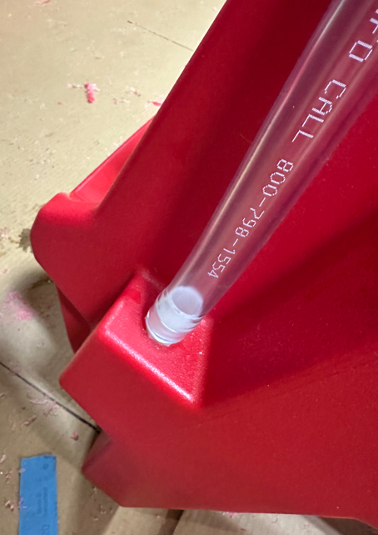

  - Take a pump (E28902) and attach it to the bottom of the tank in the orientation shown using 4 screws (E28761) and 4 washers (E28775). Be sure not to overtighten the screws since the feet on the pump are rubber. Tighten them just until the feet start to mushroom. Keep the two fittings that came with the pump.

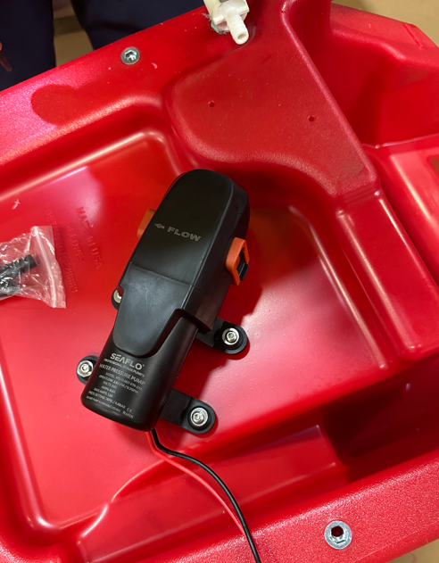
  - Cut a 1 ½” long and a 3 ¼” long piece of 3/8” hose (E28620). Take a bowl filter (E28942) and a filter mounting bracket (E28740). Assemble these items in the orientation shown. Ensure the flow direction (arrow) on the filter is oriented properly.

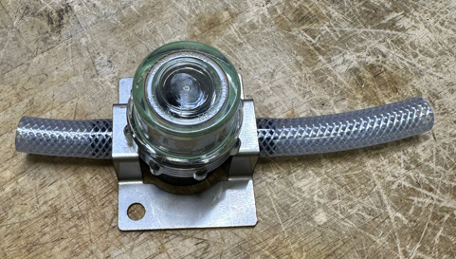
Flow Direction
3 ¼”
1 ½”

  - The pump was supplied with 2 fittings. Take the elbow fitting and push it into the hose shown (3 ¼” piece) in the correct orientation. Use a worm clamp (E89720) to secure it.

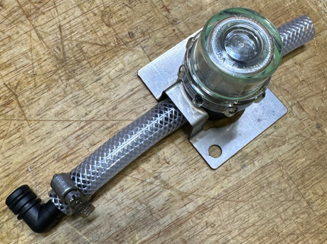

  - Cut a 4 ¼” long and a 31” long piece of 3/8” hose (E28620). Get a check valve (E28816) and push the appropriate piece of hose onto each end. Ensure the flow direction (arrow on check valve) is oriented properly. Use 2 pinch clamps (E28773) to secure the hoses to the valve.

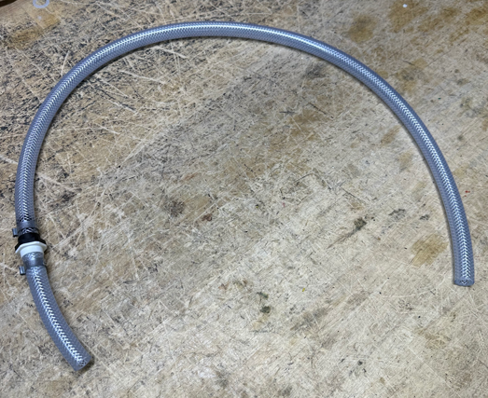
Flow Direction
31”
4 ¼”

  - Take the straight fitting that was provided with the pump and push it into the end of the 4 ¼” hose. Use a worm clamp (E89720) to secure it.

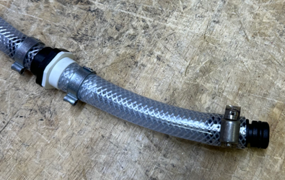
  - Take the hose assembly with the check valve and install the fitting into the outlet side of the pump as shown. Press the fitting into the port and push shut the clamp on the pump.

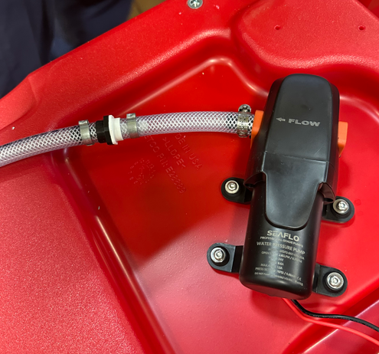

  - Take the bowl filter assembly and press the shorter hose onto the barb on the ball valve. Be sure to support the valve when pushing on the hose so that it doesn’t break. It can take a lot of force to push the hose all the way on.

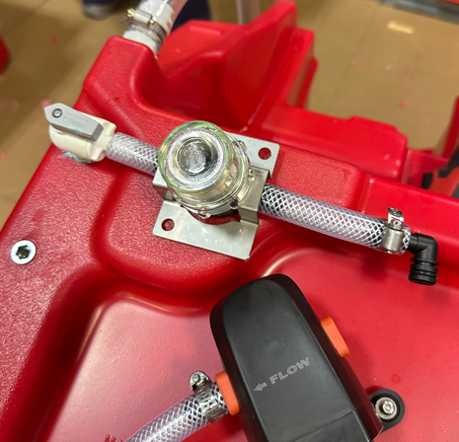
  - Use 2 screws (E29334) and 2 washers (E28775) to attach the filter bracket to the tank.

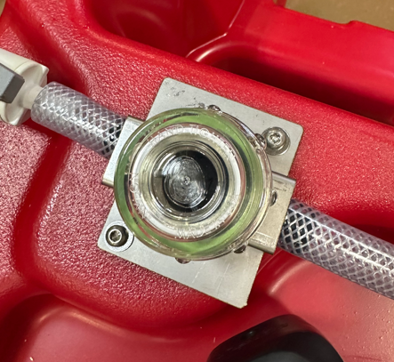

  - Push the elbow fitting into the inlet side of the pump and push the clamp shut.
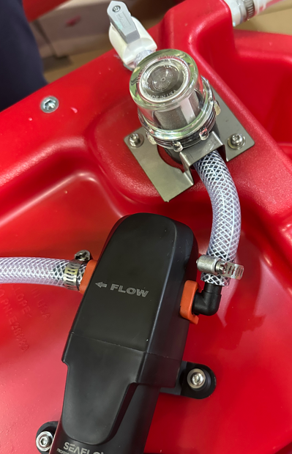
- References (optional section as needed)

- Training Guide

Functional Training Groups Requiring Training
Equipment Assembly Group

- SOP Change Control

Date of Change | Reason for Change
Rev 01 – 5/22/2025 | This is the first version of the S.O.P. hence there are no revisions to this document.

Approvals

Submitter/Author Approval:__________________________________ Date:______________________

Management Approval:______________________________________ Date:______________________

QAU Approval:_____________________________________________ Date:______________________

